

**Tribhuvan University**

**Faculty of Humanities and Social Science**

**Poshak Sewa**

**A Project Report**

**Submitted to**

**Department of Computer Application**

**Indreni College**

***In partial fulfillment of the requirements for the*** ***Bachelors in Computer Application***

**Submitted By**

**Bikal Adhikari (Registration** no.: 6-2-1133-47-2019)

April, 2023

**Under the supervision of**

**Ravi Tiwari**



**Tribhuvan University**

**Faculty of Humanities and Social Science**

**Indreni College**

**Supervisor's Recommendation**

I hereby recommend that this project prepared under my supervision by **Bikal Adhikari** entitled “**POSHAK SEWA**” in partial fulfillment of the requirements for the degree of Bachelor of Computer Application is recommended for the final evaluation.

**………………………….**

**Signature Of Supervisor**

**Ravi Tiwari**

**SUPERVISOR**

**Lecturer**

Department of Computer Application

Indreni College Bharatpur-12, Nepal

Date:

# Abstract

Online platforms, social media, websites, and mobile applications have created new platforms for entrepreneurs to build their businesses, making it easier for customers to shop, book, and rent. Online bookings, rentals and sales have created a virtual marketplace for customers to find different products around the world. Also, the online clothes rental web application in Nepal does not offer online clothes rental. I want to wear comfortably, and even if I can't afford to own clothes, I want people to enjoy it as if they were wearing their own clothes. Recognizing the needs of people, this project was developed. My application offers the possibility to book and rent clothes online. This project mainly focuses on clothes rental for people who want to wear clothes comfortably, can't afford clothes, and are worried about their personality. Developing a web application or any application involves many stages, many research, concentration, patience, and hard work. This project briefly introduces the current issues, world and Nepal scenarios. The appropriate methodology for your project will be selected, used to develop this application, and the tasks will be performed based on the methodology described in this report. It also describes all the technical terms, programming languages, and frameworks used to develop this application. Therefore, this report includes a collection of project requirements, design, implementation stages, and future plans.

# Acknowledgement

We are using this opportunity to express our gratitude to the Faculty of Humanities and Social Science Technology, Indreni College for providing us the opportunity to explore our potentiality in the field of our interest through technology via this project.

We would like to thank our Supervisor Ravi Tiwari for his kind support, coordination and valuable supervision for this project. His useful suggestion for this project and co-operative behavior are sincerely acknowledged.

We are also thankful to our HOD **Mr. Ram Binay Gupta** faculty teachers and friends who persuaded, helped us for accomplishing this project.

We would also like to acknowledge and extend our gratitude to everyone for his/her support and encouragement for this project.

# Table of Content

Abstract i

Acknowledgement ii

Table of Content iii

List of tables v

List of Figures vi

List of Abbreviations vii

Chapter 1: Introduction 1

1.1. Introduction 1

1.2. Problem Statement 1

1.3. Objective 1

1.4. Scope and Limitation 1

1.4.1. Scope 2

1.4.2. Limitation 2

1.5. Development Methodology 2

1.6. Report Organization 3

Chapter 2: Background Study and Literature Review 5

2.1. Background Study 5

2.2. Literature Review 5

Chapter 3: System Analysis 6

3.1 System Analysis 6

3.1.1 Requirement Analysis 6

3.1.2 Feasibility Analysis 8

3.1.3. Data Modeling using ER Diagram 10

3.1.4. Process Modelling DFD 10

3.2 System Design 12

3.2.1 Architectural design 12

3.2.2 Database Schema Design 13

3.2.3 Interface design (UI/UX) 13

3.3. Algorithm Details 14

Chapter 4: Implementation and Testing 15

4.1. Implementation 15

4.1.1. Tools Used 15

4.1.2. Implementation Details of Modules 15

4.2. Testing 16

4.2.1. Test Cases for Unit Testing 17

4.2.2. Test Cases for System Testing 18

Chapter 5: Conclusion and Future Recommendation 19

5.1. Conclusion 19

5.2 Lesson Learnt/Outcomes 19

5.3. Future Recommendations 19

Appendices 21

Screenshots: 21

# List of tables

Table 3. 1 Working Schedule 9

Table 4.1 Test case for unit testing 17

Table 4.2 Test case for system testing 18

# List of Figures

Figure 1. 1 Agile Development Methodology 2

Figure 3. 2 Use Case Diagram 7

Figure 3. 3 ER Diagram 10

Figure 3. 4 Level 0 DFD 11

Figure 3. 5 Level 1 DFD 12

Figure 3. 6 Level 2 DFD 12

Figure 3. 6 Architectural Design 13

Figure 3. 7 Database Class Diagram 13

Figure 3. 8 Ui of Poshak Sewa 13

# List of Abbreviations

* IDE - integrated development environment
* VS Code – Visual Studio Code
* API – Application Programming Interface
* ER Diagram – Entity Relationship Diagram
* MySQL – My Structured Query Language.
* ORM – Object–relational mapping
* SEO – Search Engine Optimization
* CSS – Cascading Style Sheet
* DOM – Document Object Model
* ID -Identity Number
* Etc. - Et Cetera
* & - And

# Chapter 1: Introduction

## 1.1. Introduction

The clothing rental industry has seen a surge in recent years, driven by increasing environmental concerns and a shift towards a more sustainable and circular economy. This project aims to develop a cloth rental service that gives customers the opportunity to rent fashionable clothing for special occasions and events. By offering this service, we hope to reduce the environmental impact of fast fashion, while also providing a cost-effective and convenient solution for customers who want to wear stylish clothing without having to purchase it outright.

## 1.2. Problem Statement

In today's world, fast fashion has led to an increase in clothing waste, which has a significant impact on the environment. People often buy clothes that they wear only a few times before discarding them, contributing to the problem of textile waste. Additionally, buying new clothes regularly can be expensive, and not everyone can afford to keep up with the latest fashion trends.

* Fast fashion harms the environment; a cloth rental website can promote sustainability.
* Cloth rental may face higher return rates due to sizing and condition issues.
* Address hygiene concerns with proper cleaning and disinfecting protocols.

## 1.3. Objective

Our project would solve the above-mentioned problem by providing the proper information about the specialist and user can view specialist based on their problem from single click as well as their time schedule. Objectives are:

* To create a user-friendly and intuitive online platform where customers can easily browse and rent clothing for various occasions.
* To provide a diverse range of high-quality and fashionable clothing options that cater to unique styles, sizes, and preferences.
* To establish a sustainable and environmentally conscious business model that promotes the reuse and recycling of clothing.

## 1.4. Scope and Limitation

### 1.4.1. Scope

“Poshak Sewa” will feature an extensive product catalog that includes two categories i.e., Men and Women. The catalog will be well-organized, making it easy for customers to find and select products. The website will be designed with a user-centric approach, focusing on simplicity, easy navigation, and intuitive interfaces. Mobile responsiveness will be a priority to cater to customers shopping on smartphones and tablets.

### 1.4.2. Limitation

Ecommerce platforms can encounter technical challenges such as server downtime, slow loading times, and software bugs. Ensuring consistent website performance and stability is essential to provide a positive user experience. Managing a diverse range of perishable and non-perishable clothing items can be complex. Ensuring real-time stock updates, accurate product information, and minimizing stock outs require efficient inventory management systems.

## 1.5. Development Methodology

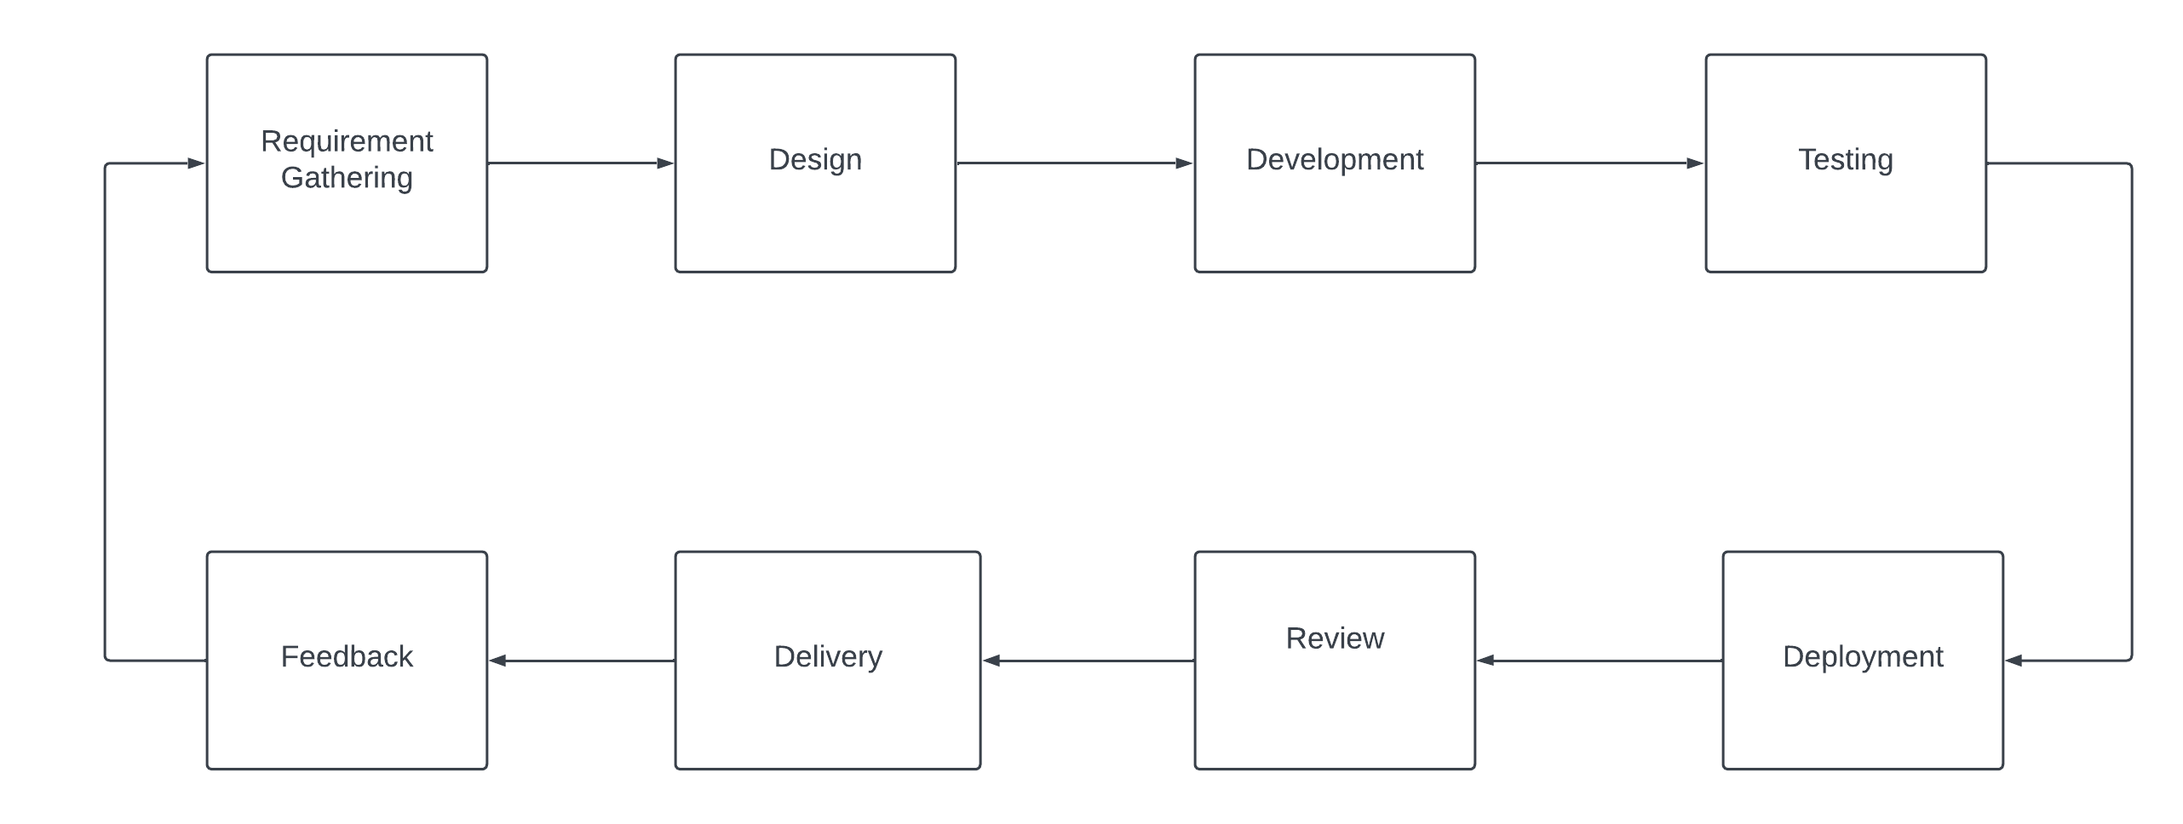

Figure 1. 1 Agile Development Methodology

Agile Development methodology is used for developing Poshak Sewa Web Application, as it emphasizes collaboration, flexibility, and iterative development. Agile is an incremental approach to software development, where the app is developed in small chunks or sprints, with each sprint building on the previous one.

In Agile Development, the project team consists of developers, product owners, and stakeholders, who collaborate closely throughout the development process. The development process is divided into small sprints, typically 2-4 weeks in duration, where the team works on a specific set of features or functionality. At the beginning of each sprint, the team holds a planning meeting, where they discuss the goals and objectives for the sprint and define the features and functionality that will be developed. During the sprint, the team works on developing the defined features and functionality, and adjust as necessary.

## 1.6. Report Organization

Chapter Plan regarding our project is structured as specified in the format below:

**Chapter 1: Introduction**

This chapter consists of a brief introduction to my Project “Poshak Sewa”. This chapter also discusses about the statements of problem, the objectives of the project, its scope and limitations.

**Chapter 2: Requirement Analysis and Feasibility Study**

This chapter focuses on the study of existing system and projects from various sources such as websites, journals, project works and reports. It also explains the requirements specification and feasibility study conducted during project initiation.

**Chapter 3: System Design**

This chapter includes studying a procedure or business in order to identify its goals and purposes and create systems and procedures that will achieve them in an efficient way. It also explains the requirements specification and feasibility study conducted during project initiation. This chapter consists of High-Level Design, Data Flow Diagram (DFD), Use Case Diagram.

**Chapter 4: Implementation and Testing**

This chapter focuses on the Software, Tools, and Protocols that have been utilized for the initiation and completion of our Project. Also, it defines various testing of the System.

**Chapter 5: Conclusion and Future Upgrades**

This section depicts the overall conclusion of the project and future upgrades that will be required for the next roadmap of the project.

**References**

This section lists out references of journals, conferences, and others sources that have been cited throughout the project.

**Appendix**

This section includes the miscellaneous screenshots, source codes, and configuration files that explain the working mechanism of our project.

# Chapter 2: Background Study and Literature Review

## 2.1. Background Study

"Poshak Sewa is an innovative online clothing rental platform that connects users with a wide range of stylish clothing options. Designed with cutting-edge web technologies, this platform ensures a smooth and reliable experience for users. The user-friendly interface simplifies the process of browsing and renting attire, making it easy for customers to find the perfect outfit.

Poshak Sewa offers a comprehensive clothing rental solution, including essential tools such as hosting, elegant design, flexible pricing, secure payment options, marketing features, and insightful reports. In our research, we've developed an effective recommendation system that analyzes customers' past rental orders and suggests clothing items that align with their preferences, enhancing their overall experience.

Our methodology is built upon a review of various recommendation algorithms, ensuring that Poshak Sewa continues to provide top-notch clothing rental services. With a focus on user satisfaction and convenience, Poshak Sewa is your go-to destination for hassle-free clothing rentals."

## 2.2. Literature Review

The cloth rental business model is gaining popularity due to its environmental and economic benefits. Renting clothes reduces textile waste and allows consumers to have access to a wider variety of outfits without having to purchase them outright. Studies have also shown that consumers are becoming more interested in sustainability and are willing to support businesses that align with their values. However, some challenges associated with cloth rental websites include maintaining the quality and cleanliness of the clothing, as well as the potential for theft or damage. Overall, the research suggests that cloth rental websites have the potential to be a successful and sustainable business model in the fashion industry.

# Chapter 3: System Analysis

## 3.1 System Analysis

It includes collecting and interpreting facts, identifying the problems, and decomposition of a system into its components. System analysis is conducted to study a system or its parts to identify its objectives. It is a problem-solving technique that improves the system and ensures that all the components of the system work efficiently to accomplish their purpose. It consists of requirement analysis and feasibility study for the system.

### 3.1.1 Requirement Analysis

Requirement Analysis, also known as Requirement Engineering, includes defining user expectations for a new software being built or modified. In software engineering, it is sometimes referred to loosely by names such as requirements gathering or requirements capturing. It includes functional and non-functional requirement for the system.

1. **Functional Requirements**

Poshak Sewa system was developed using M1 processor, Node.js (Intel IDE) for react and laravel for backend since this project uses database and control, it needs the retrieval of information from the database. It needs access of Database from a backend, as MySQL Database Service is a fully managed database service to deploy cloud-native applications it provides easy linking to the database, along with the flexibility required to develop a user-friendly front end. Major functional Requirements can be listed as:

• Enter Website and Login in

• Log out

• Verification and Validation

• Manage Users

**3.1.1.1 Use Case Diagram**

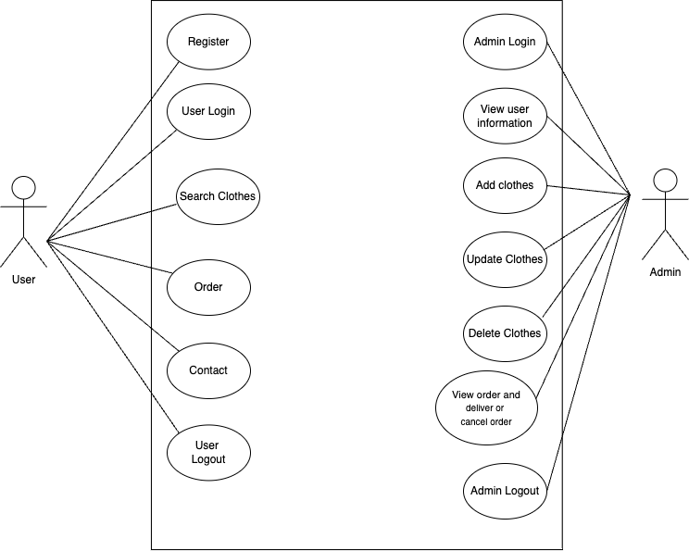

Figure 3.1.1.1 Use Case Diagram



1. **Non-Functional Requirements**

There are several non-functional requirements that must be met for the Poshak Sewa website to be successful. These non-functional requirements relate to the overall performance, reliability, and usability of the platform, and are essential for ensuring that users have a positive experience when using the platform.

* Performance: The platform must be fast and responsive, with minimal lag or delay when accessing or using any of its features.
* Reliability: The platform must be highly reliable, with a high degree of uptime and minimal downtime. The platform should also be able to handle a high volume of traffic without slowing down or crashing.
* Scalability: The platform must be designed with scalability in mind, and should be able to accommodate growth and increased usage over time.
* Security: The platform must include robust security measures to protect user data and ensure the confidentiality and privacy of user information.
* Usability: The platform must be easy to use and navigate, with a user-friendly interface that makes it simple for users to find and access the information and features they need.
* Accessibility: The platform must be accessible to users with a range of abilities and disabilities, including those with visual, auditory, and motor impairments.

In order to ensure the success of the Poshak Sewa platform, these non-functional requirements were identified and will be incorporated into the design and development of the platform, to ensure that users have a positive and seamless experience when using the platform.

### 3.1.2 Feasibility Analysis

1. **Technical Feasibility**

The technical feasibility education contains study of function, presentation and restraints that may move the ability to achieve a suitable system. For this possibility study, we deliberate whole functionality to be in the organization, as labelled in the System Obligation Specification (SOS), and checked if the whole thing was possible using the different types of frontend and backend podiums. We require SQL database management, XAMPP, Sublime Text framework that are all easily available with extensive development support through manuals and blogs. Hence our project is technically feasible.

1. **Operational Feasibility**

Our proposed system just requires minimalistic configuration on web browsers and connectivity to the Internet. As these requirements can be easily fulfilled, our proposed system is operationally feasible.

1. **Economic Feasibility**

This is very important aspects to be considered while developing a project. We decided the technology for our project founded on smallest conceivable charge influence.

• Entirely tools and system fee obligate to be done by developer.

• Completely we have projected that the benefits the creator is going to receive from the planned system will surely dazed the initial prices and the later on organizational cost for system.

1. **Schedule Feasibility**

Table 3. 1 Working Schedule

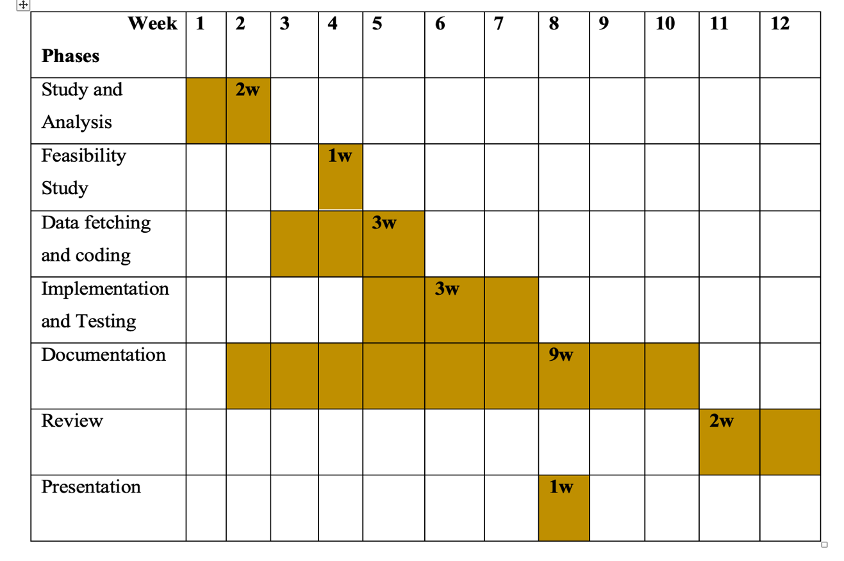

### 3.1.3. Data Modeling using ER Diagram

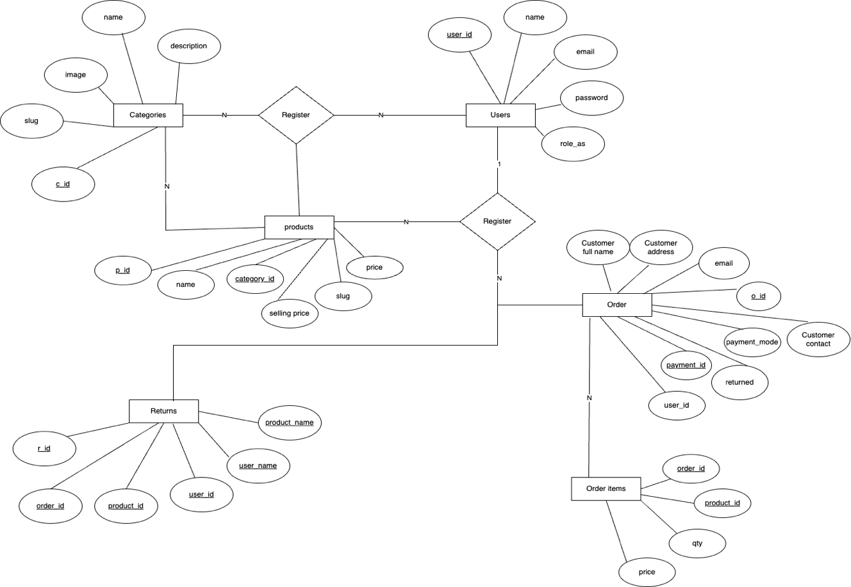

Figure 3. 3 ER Diagram

### 

### 3.1.4. Process Modelling DFD

Figure 3. 4 Level 0 DFD

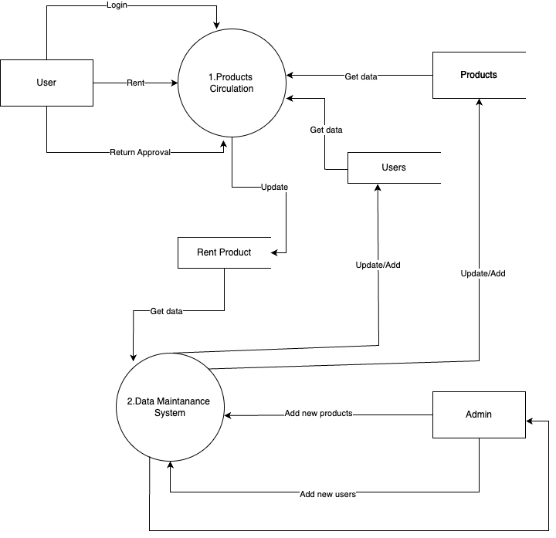

**Figure 3.5 Level 1 DFD**

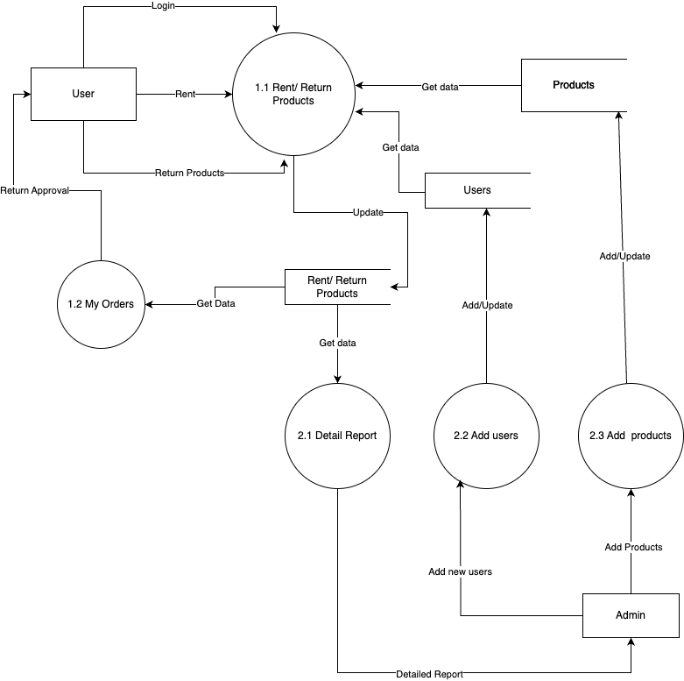

**Figure 3.6 Level 2 DFD**

### 3.2 System Design

In System design, we transform the human readable requirements into actual code. For which we have used UML diagrams. On that we have used Use Case diagram, ER-diagram, Data Flow diagram. In these diagrams, we have tried to explain the system in better and simple ways. 3.1.1 Database Schema Design these are system classes, their attribute, operations and the relationships among objects.

### 3.2.1 Architectural design

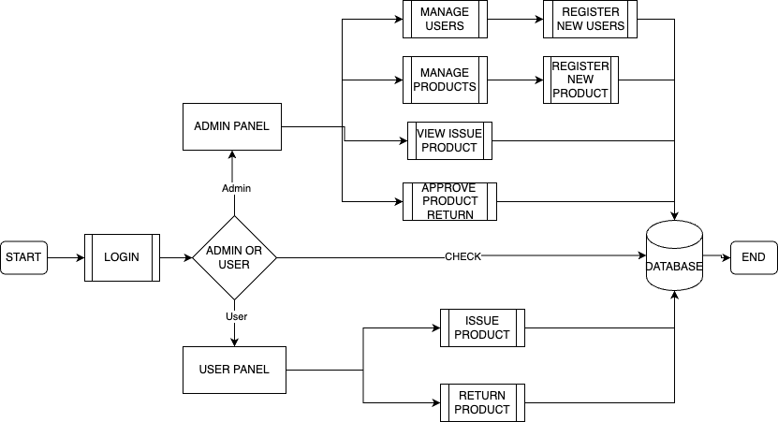

**Figure 3.7: Architectural design**

### 3.2.2 Database Schema Design

These are system classes, their attribute, operations and the relationships among

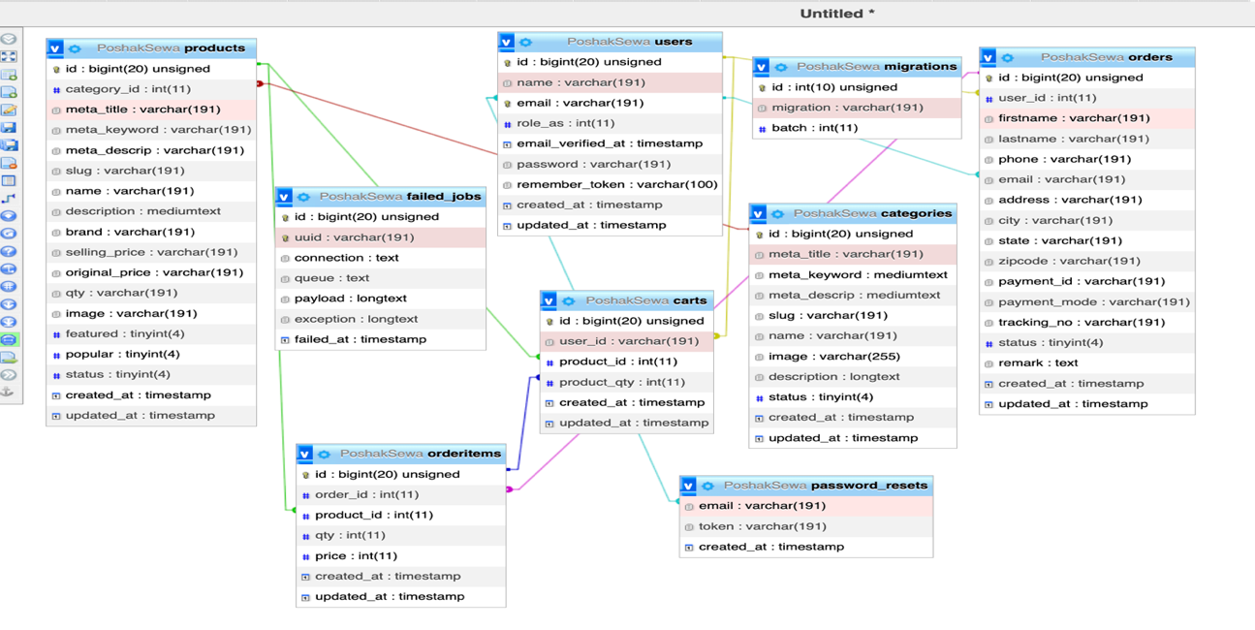

**Figure 3.8: Database Class Diagram**

### 3.2.3 Interface design (UI/UX)

UI refers to the screens, buttons, toggles, icons, and other visual elements that you interact with when using a website, app, or electronic device. UX refers to the entire interaction you have with a product, including how you feel about the interaction.

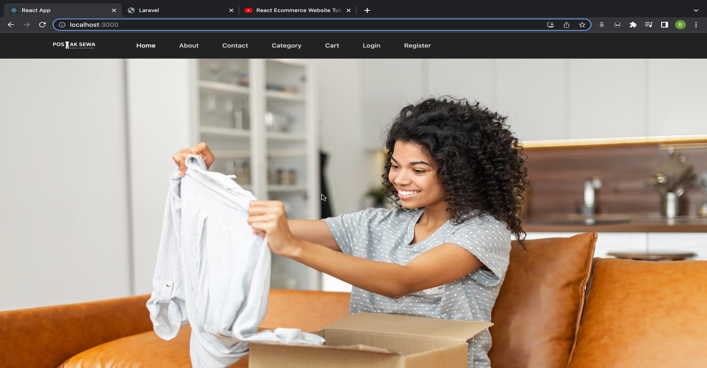

**Figure 3.9: Ui of Poshak Sewa**

## 3.3. Algorithm Details

To achieve this functionality, the G-mart website uses modern web technologies and frameworks, such as React to create a dynamic and user-friendly interface.

* **Search Algorithms**: Search algorithms like Binary Search or Linear Search are used to locate specific elements within data sets efficiently.

const handleSearch = (event) => {

const query = event.target.value.toLowerCase();

setSearchQuery(query);

const filtered = product.filter(

(product) =>

(product.name && product.name.toLowerCase().includes(query)) ||

(product.about && product.about.toLowerCase().includes(query))

);

setFilteredProducts(filtered);

};

* **Hashing Algorithms**: I have usedHashfunction, which also known asBcrypt is a widely used and secure password hashing algorithm that incorporates a salt (a random value) and multiple rounds of hashing to protect against brute-force attacks and rainbow table attacks.

'password' => Hash:: make($request-> password),

# Chapter 4: Implementation and Testing

## 4.1. Implementation

### 4.1.1. Tools Used

**a) React js:**

React.js is an open-source JavaScript library developed by Facebook that is widely used for building user interfaces (UIs) for web applications. React allows developers to create reusable UI components and efficiently manage the dynamic updating of the UI based on changes in data. It uses JavaScript.

**b) HTML:**

HTML is format that tells a computer how to display a web page. We use HTML in this web portal for creating forms and table layout.

**c) CSS:**

CSS (Cascading Style Sheet) is the style sheet language for styling the HTML elements. I use tailwindcss one of the frameworks of CSS that help us to manage font-family, content sizes and other various content for styling in this web portal.

**d) PHP:**

PHP codes run in the server and stores in PHP scripts that usually have a .php file extension. All backend as well as frontend codes are based on PHP in this web portal.

**e) SQL:**

SQL (Structured Query Language) is a standard language for accessing and manipulating databases. SQL is query language used to communicate with a MYSQL database I create database for web portal by accessing in <http://localhost/phpmyadmin/>.

**d) Visual studio code:**

Visual Studio Code, also commonly referred to as VS Code, is a source-code editor made by Microsoft with the Electron Framework, for Windows, Linux and macOS. Features include support for debugging, syntax highlighting, intelligent code completion, snippets, code refactoring, and embedded Git.

### 4.1.2. Implementation Details of Modules

A modularization is a well-organized system that consists of manageable units with clear interface among them.

This project consists of following modules:

* Signup/ Login Module: This module is responsible for the user registration and user login.
* Session Module: This module is responsible for handling session when user login to the system.
* Order products Module: This module is responsible for handling the products/items posted by the registered user.
* Manage order Module: This module is responsible for handling the manage orders by the registered users who can edit/delete orders.
* User Listing Module: This module handles the user listing which only can be accessed by admin only.

## 4.2. Testing

Testing is the process of evaluation of a software to detect difference between given input and expected output. Testing is a process that should be done during the development process.

The Unit testing part of a testing methodology is the testing of individual software modules or components that make up an application or system.

### 4.2.1. Test Cases for Unit Testing

Table 4.1 Test case for unit testing

|  |  |  |  |  |  |
| --- | --- | --- | --- | --- | --- |
| **Test case** | **Preconditions** | **Steps to be Executed** | **Expected Results** | **Actual Results** | **Pass/Fail** |
| Login for admin | The admin account should be registered | Enter username and password click login | Admin must successfully login to the profile | Admin is successfully logged in | Pass |
| Login for admin | The admin account should be registered | -Enter incorrect username and password -Click Login | Admin cannot access admin profile | Invalid username or password | Pass |
| Admin task | Product and category added | -Enter details  -Click add category/product | Admin must successfully add the category &product. | Admin has successfully added the category &product. | Pass |
| Register user | For creating account for user | -Enter name, email address, and password  -Click on Register | Account must be created. | Account is created. | Pass |

### 4.2.2. Test Cases for System Testing

The system testing part of a testing methodology involves testing the entire system for error and bugs. This test is carried out by interfacing the hardware and software components of the entire system, and then testing it as a whole.

Table 4.2 Test case for system testing

|  |  |  |  |
| --- | --- | --- | --- |
| SN | Test Case | Expected Result | Actual Result |
| 1 | Trying to login leaving blank textbox | login error indicating please fill out form | As expected, |
| 2 | Trying to login with invalid username | Login error indicating fill out this field | As expected, |
| 3 | Trying to login with different password | Login error indicating invalid password | As expected, |
| 4 | Check the status of user details. | Shows the details | As expected, |
| 5 | Check the status of order details. | Shows the details | As expected, |

# 

# Chapter 5: Conclusion and Future Recommendation

## 5.1. Conclusion

Poshak Sewa, the cloth renting website, has been an exciting and rewarding journey. The primary goal of this project was to create a user-friendly and efficient platform that provides a seamless renting experience for customers looking to rent stylish clothes online. With the completion of the project, I am pleased to say that this objective has been successfully met. Throughout the development process, careful attention was given to design, functionality, and performance. The website's modern and intuitive user interface ensures that customers can easily navigate through different sections, browse products, and make purchases with minimal effort. The integration of a responsive design ensures a consistent experience across various devices, from desktop computers to smartphones and tablets. Additionally, the cart and checkout process have been streamlined to ensure a hassle-free transaction, from product selection to payment confirmation. Moreover, Poshak Sewa’s administration panel empowers store owners to manage inventory, update product details, and process orders efficiently. This administrative interface has been designed to be user-friendly and accessible, even for individuals with limited technical expertise.

Overall, the completion of Poshak Sewa marks a significant milestone in the realm of online cloth renting. It has been a challenging but fulfilling experience to develop this platform, and I am grateful for the knowledge and expertise gained throughout the process. As a developer, I am proud of the final product and confident that Poshak Sewa will offer immense value to both customers and store owners alike.

## 5.2 Lesson Learnt/Outcomes

We can expect a fully functional website that can meet all the necessary needs of peoples. Easy and simple user interface that can be used by all age groups and beginners, an affordable and interesting kinds of products.

## 5.3. Future Recommendations

We intend to do the following tasks in the coming future to make it more competitive.

• Automated Report Generation.

• Make compatible to all browsers.

• User friendly Smart Cloth renting Application (apk).

References

I. “Rent the runway,” RenttheRunway. [Online]. Available: https://help.renttherunway.com/. [Accessed: 24-Apr-2023].

II. “Clothing Rental+Resale Marketplace,” Nuuly. [Online]. Available: http://www.nully.com/. [Accessed: 24-Apr-2023].

# Appendices

## Screenshots:

**Home Page**

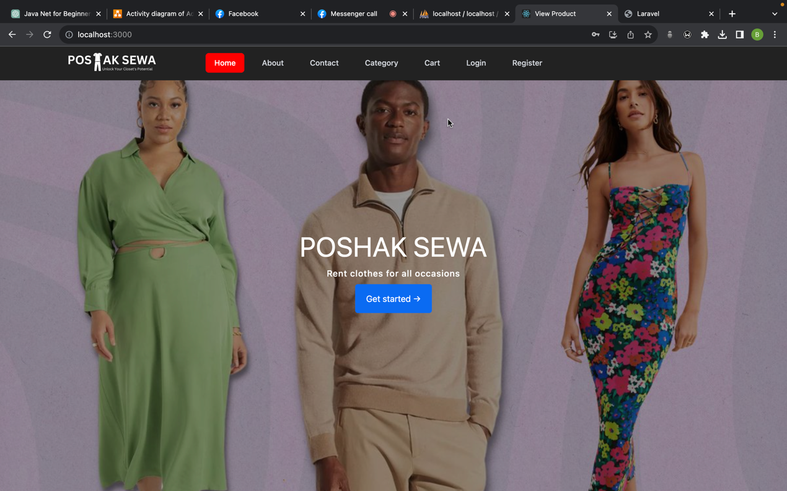

**Category**

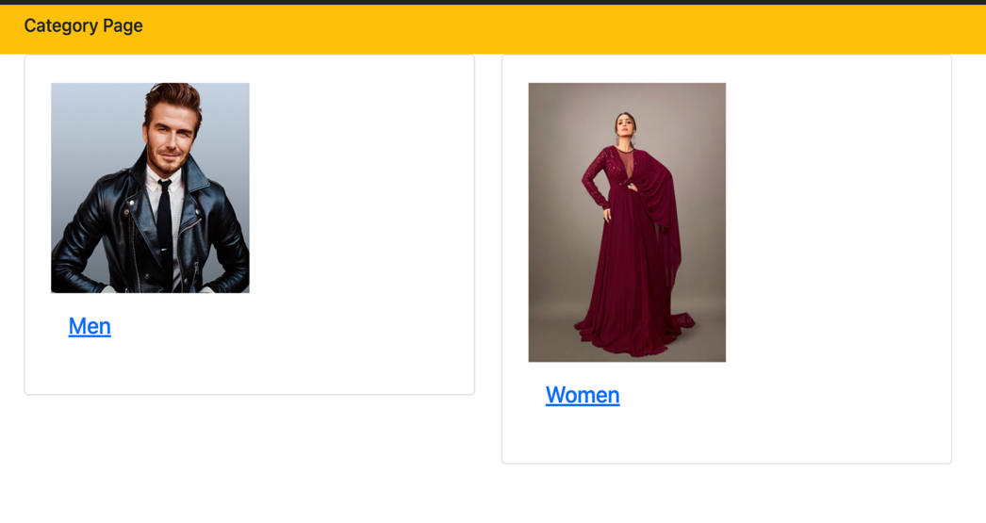

**Sign Up**

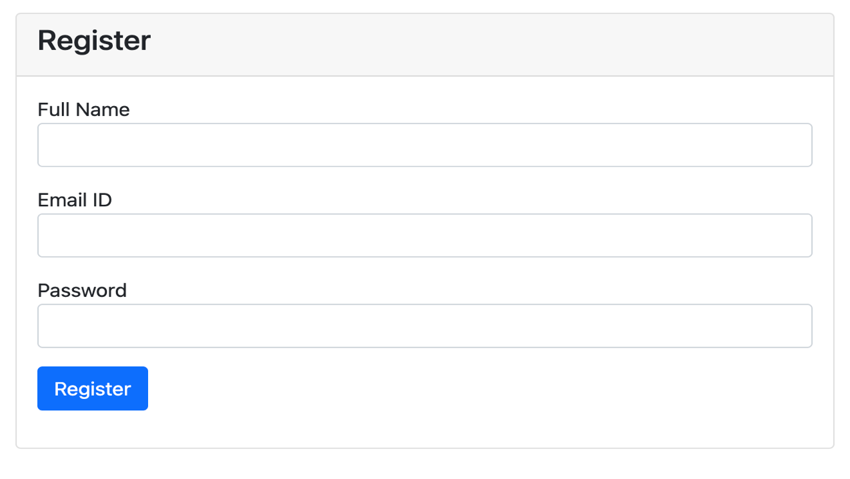

**User Login**

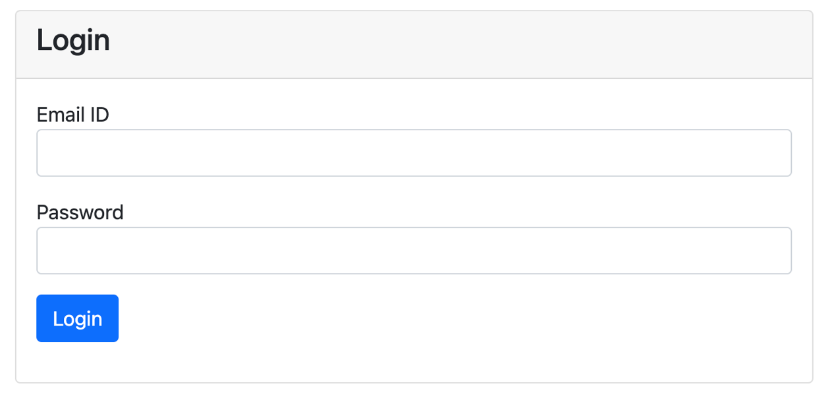

**Product Page**

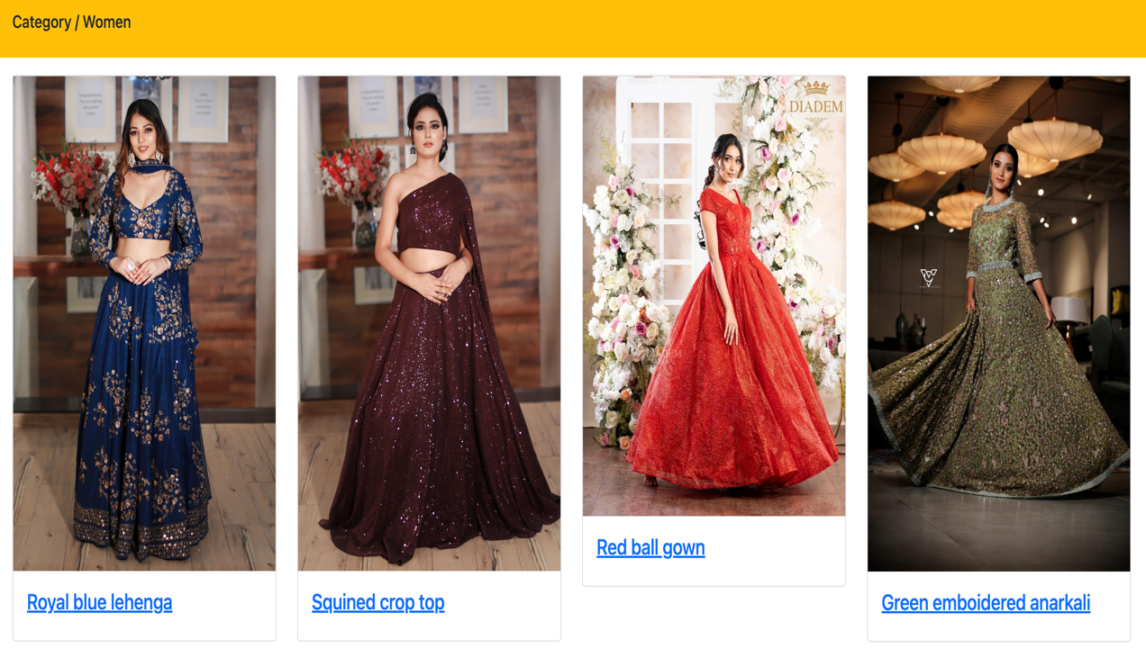

**Product Detail**

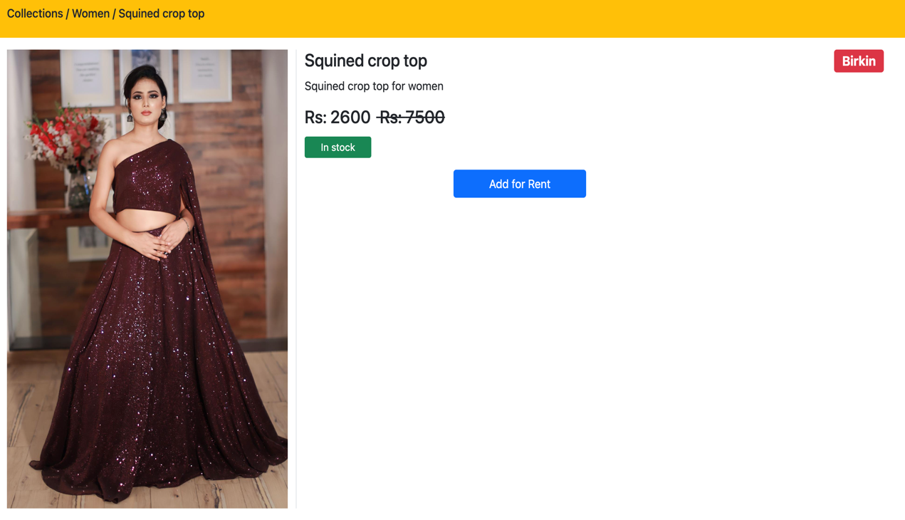

**CheckOut**

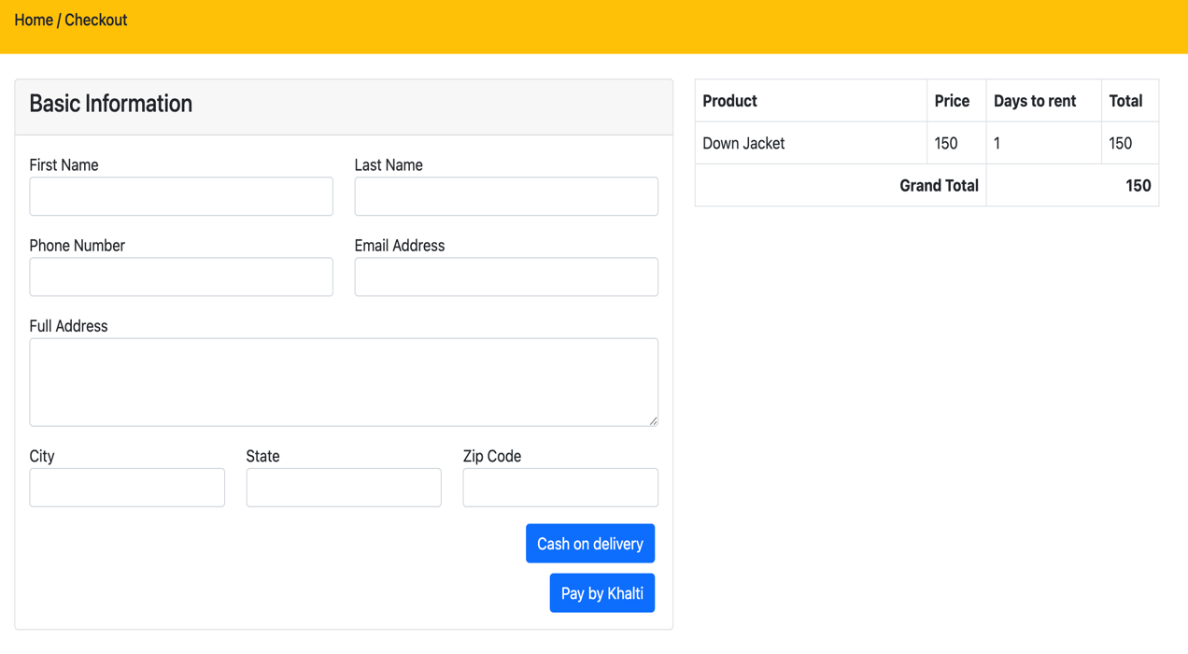

**List of Products**

